DV1435 High-Level Design

Thomas Sievert, Martin Säll, Lars Woxberg ,Kim Restad & Fredrik Johannesson

# Project description

Pacman::Reloaded is a 3D rendition of the timeless classic Pacman.

The game starts with a title screen, where there are four options: Play the game, view the highscore, view the credits, and quit the game. The game has a set number of stages for Pacman to go through. When he has finished them all, he is sent back to the first stage, on a slightly harder difficulty. Thus, the game goes on indefinitely, or until Pacman dies. When the game is over, the player might be registered to the highscore list.

# Architecture

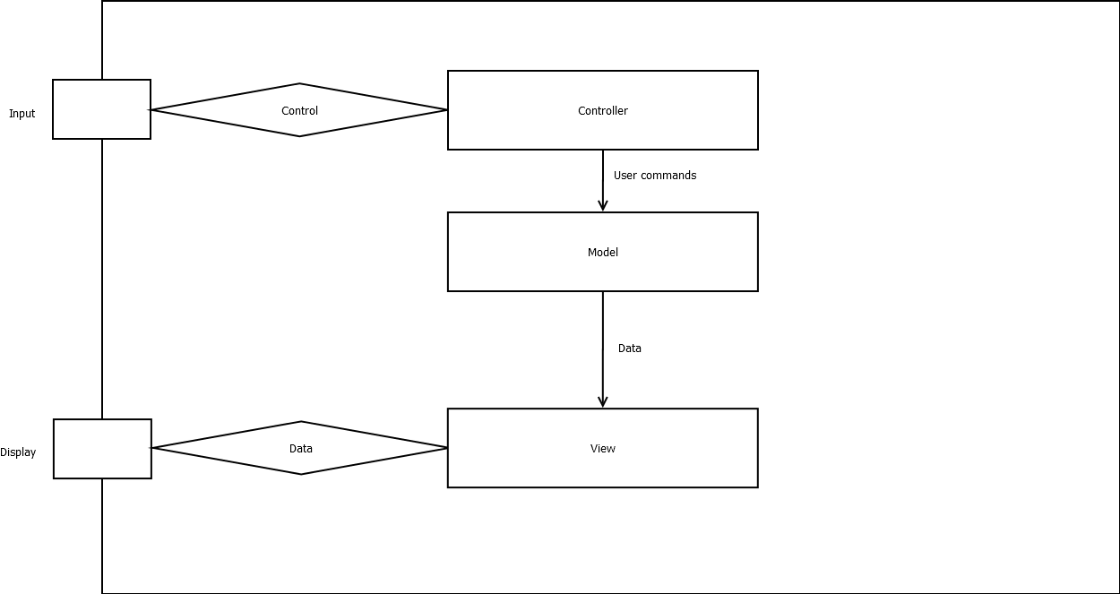

The system will contain three distinct packages: Model, View and Controller.

Input is collected from the keyboard and sent to the Controller package. The Controller translates the input to user commands and passes them on to the Model package. The game logic is inside the Model package, and is updated according to the user commands. Further data is sent to the View package, to render Pacman in our 3D environment. This structure is our basic game loop.

# Work breakdown structure